Question 3:
Store five movies and their release years. Print the release year of each movie.
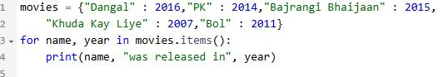
Output:
